 | Autumn 1 | Autumn 2 | Spring 1 | Spring 2 | Summer 1 | Summer 2
Possible Themes/Interests/Lines of Enquiry | Settling In /Feelings  All About Me  God’s World  Autumn  Harvest  Bears  Teddy Bears Picnic  Woodland | Autumn  Day & Night  Remembrance Day  Bonfire Night  Space  Christmas | Winter  Valentine’ Day  Chinese New Year  Dragons Knights & castles | Around The World  Pancake Day  Mother’s Day  Easter | Sports day | Father’s Day  Transition
Focus Texts with taught vocabulary | (4^{th and 9th} Sept) Theme: Feelings  Colour Monster by Anna Llenas  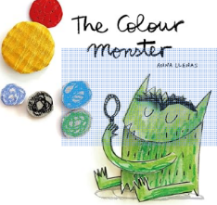  Feelings  Happiness  Sadness  Fear  Calm  Anger | (28th Oct) Theme: Autumn day & Night  After the Storm by Nick Butterworth  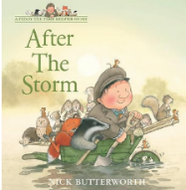  Storm, Thunder, Lightning, Wind, Damage, Repair | (6th and 13th Jan) Theme: Winter  Stickman By Julia Donaldson  Stick  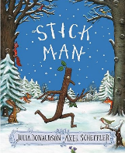  Twig  Mast  Beach  Bow  Grate  Chimney | (25th Feb) Theme: Around the World  Outside My Window By Linda Ashman  Magnolia    River  Mountain  Boulevard  Alleyway  Ocean | (28th April and 5th May) Theme: Growing Jack and the Jelly Beanstalk By Racheal Mortimer  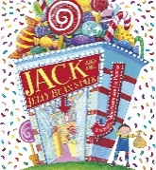  Beanstalk  Giant  Goose  Harp  Feast | (9th and 16th June) Theme:Transport  The Train Ride By June Crebbin  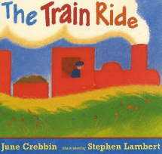  Journey  Meadow  Ticket collector Tunnel  Lighthouse  Engine
Supplementary Texts | 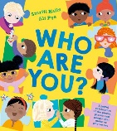  Who are you? By Smriti Halls  You’re So Amazing By James Catchpole | 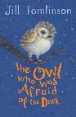  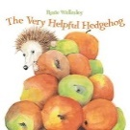  The Very Helpful Hedgehog By Rosie Wellesley  The Owl Who Was Afraid Of The Dark By Jill Tomlinson | 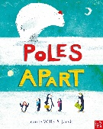  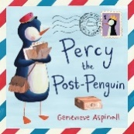  Percy the Post Penguin By Genevieve Aspinall  Poles Apart By Jeanne Willis |   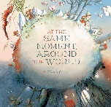  At the same moment, around the world By Clotilde Perrin  The Book With No Pictures By B.J.Novak | 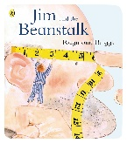  Jim And The Beanstalk By Raymond Briggs  Shhh! By Sally Grindley | 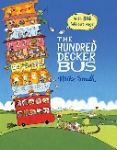  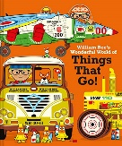  The Hundred Decker Bus By Mike Smith  William Bee’s Wonderful World of Things That Go By By William Bee (Non-Fiction)
 | (9th Sept) Theme: All about me  Super Duper You! Sopy Henn  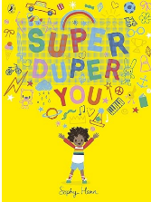  Proud  Different  Super  Grow  Twinkly  Bold | (4th Nov) Theme: Diwali/Bonfire Night  The Best Diwali Ever By Sonali Shah    Diwali  Temple  Indian  Festival  Rangoli  Divas | (20th Jan) Theme Dragons/Knights/Castles  Zog By Julia Donaldson  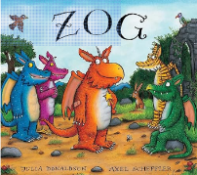  Dragon  Practise  Soared  Fearsome  Capture  Zigzagged | (3rd March) Theme: Pancake Day  Mr Wolf’s Pancakes By Jan Fearnley  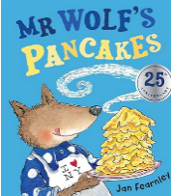  Recipe  Ingredients  Money  Cook  Shopping List | (12th and 19th May) Theme: Minibeasts  The Very Hungry Caterpillar By Eric Carle  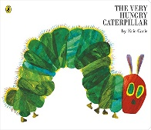  Egg  Cocoon  Nibbled  Caterpillar  Butterfly  Hungry | (23rd and 30th June) Theme: Under the Sea. The Rainbow Fish By Marcus Pfister  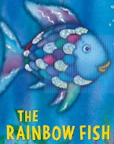  Sparkling  Shimmering  Glimmering  Flashing  Glittering  Shiny
Supplementary Texts | 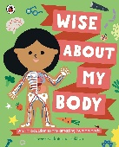  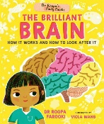  Dr Roopa’s Body Books: The brilliant brain by Dr Roopa Farooki (Non-Fiction)  Wise about my body: An introduction to the human body (Non-Fiction) | 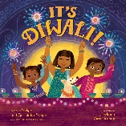  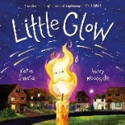  Little Glow By Katie Sahota  It’s Diwali By Kabir Sehgal (Non-Fiction) | 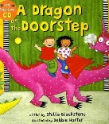  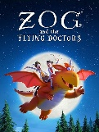  Zog and The Flying Doctors By Julia Donaldson  A dragon on The Doorstep By Stella Blackstone | 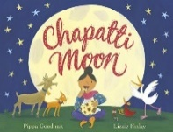  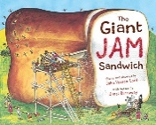  Chapatti Moon By Pippa Goodhart  The Giant Jam Sandwich By John Vernon Lord | 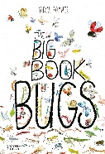  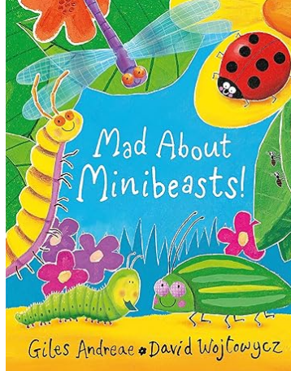  Mad about Minibeasts By Giles Andreae  The Big Book Of Bugs By Yuval Zommer | 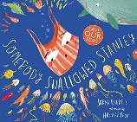  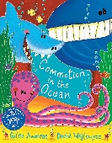  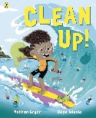  Clean up! By Nathan Bryon  Commotion In The Ocean By Giles Andreae  Somebody Swallowed Stanley By Sarah Roberts
 | (16th Sept) Theme: Homes  On the way home by Jill Murphy  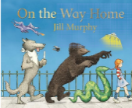  Sneaking  Zooming  Lumbering  Slithering  Gliding  Soaring | (11th and 18th Nov) Theme: Traditional Tales  The Three Little Pigs An Architectural Tale By Linda Newbery  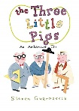  Scraps  Glass  Stone/Concrete  Greenhouse  Architect  Build | (27th Jan) Theme: Chinese New Year  The Great Race By Emily Hiles  Sparkled  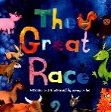  Swayed  Breeze  Emperor  Shore  Wise | (10th and 17th March Theme: Animals  Handa’s Surprise By Eileen Browne  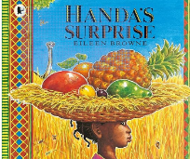  Juicy  Ripe  Sweet Smelling  Spiky  Tangy  Guava |  | (7th and 14th July) Theme: Transition  Blow a Kiss By Joseph Coelho  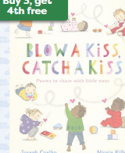
 | 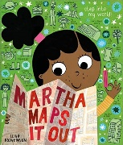  Martha Maps it out By Leigh Hodgkinson  Home by Carson Ellis | 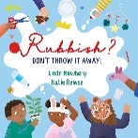  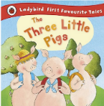  Three Little Pigs By Ladybird  Rubbish? Don’t Throw It Away By Linda Newbery |   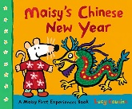  Chinese New Year By Nancy Dickman  Maisy’s Chinese New Year By Lucy Cousins | 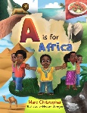  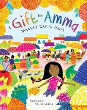  A is for Africa By Louisa Olafuyi (Non-Fiction)  A gift for Amma By Meera Siriam
 | (23rd and 30th Sept) Theme: Bears  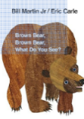  Brown Bear Brown Bear What do you see By Eric Carle  Red bird  Yellow Duck  Blue Horse  Green Frog  Purple Cat  White Dog ETC | (25th Nov and 2nd Dec) Theme: Space  How to Catch a Star Oliver Jeffers  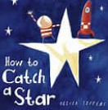  Stars  Appear  Waited  Spaceship  Fallen  Floating | (3rd and 10th May) Theme: The Gingerbread Man  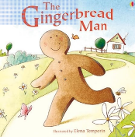  Gingerbread  Catch  Chase  Baker  Clever  Crept | (24th and 31st March) Theme: Superheroes Supertato By Sue Hendra  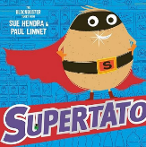  Supermarket  Conveyor Belt  Vegetables  Vanished  Freezer  Crept
 | 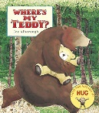  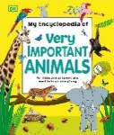  My Encyclopaedia of Very Important Animals by DK  Where’s My Teddy By Jez Alborough | 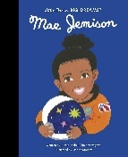  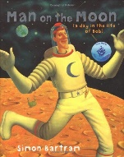  Man on the Moon By Simon Bartram  Mae Jemison By Maria Is Vegagra | 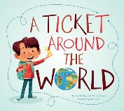  A Ticket Around The World By Natalia Diaz and Melissa Owens. | 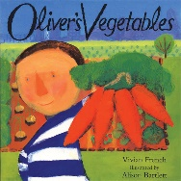  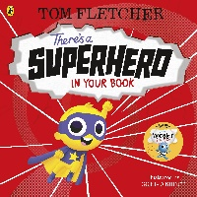  There’s a Superhero In Your Book By Tom Fletcher  Oliver’s Vegetables By Vivian French
 | (7th Oct) Theme: Harvest  The Little Red Hen By Ladybird  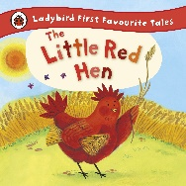  Farmyard  Wheat  Grains  Flour  Mill  Baker | (9th and 16th Dec) Theme: Christmas  The Jolly Christmas Postman Janet & Allan Ahlberg  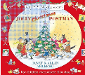  The Birth of Jesus By Cathy Jones  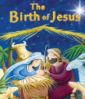  Nativity Mary, Joseph, Jesus, Angel Gabriel, shepherds, angels, wise men |  | (14th April) Theme: Easter  The Bunny Who Came for Breakfast By Rachael Davis  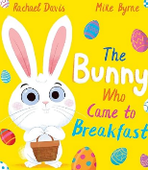
Supplementary Texts | 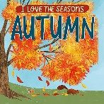  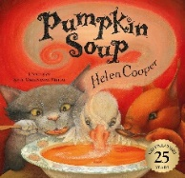  Pumpkin Soup by Helen Cooper  I love the seasons: Autumn By Lizzie Scott (Non-Fiction) |  |  | 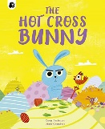  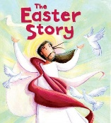  The Easter Story By Katherine Sully  The Hot Cross Bunny By Carys Bexington
(14th Oct) Theme: Autumn
The Leaf Man By Lois Ehlert
North/East/South/West
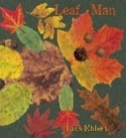
Prairie Meadows
Lake Breeze
Winter Squash
Rustlle
Drifting
Supplementary Texts | 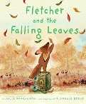  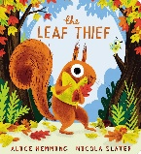  The Leaf Thief by Alice Hemming  Fletcher And The Falling Leaves By Julia Rawlinson
Experiences | Making bread  Autumn Walk  Visiting Church  Pray, stay and play sessions | Posting letters to the post box. Sending and receiving letters.  Teddy Bears Picnic  Harvest Festival.  Nativity play.  Visiting Church  Pray, stay and play sessions. | Chinese New Year Party - Dragon Dancing, tasting Chinese food.  Winter Walk  Building Snowmen  Visiting Church  Pray, stay and play sessions. | Making Pancakes  Visiting Church  Mother’s Day Assembly  Baking Easter Nests  Pray, Stay and Play | Growing Beans  Visiting Church  Tasting Fruit  Sports day | Visiting Church  Enterprise Week  Sports Day  Pray, stay and Play.  Father’s Day Stay & Play
RE | God’s World  To know that God loves and cares for each one of us and reflect on this.  Hear about and respond to the things God created for us.  Know that God has asked us to care for the world. Think of ways in which we can help to do it. To know that God made each one of us different and special. Reflect on this. | God’s Family  Be aware that God made all the people in the world to be part of his family and that we are part of it too. Know that God made us to know and love him and to show our love for him by helping one another. To know that God has given us gifts so that we can show his love to others. To know that God’s greatest gift was to send his only son Jesus and respond to that gift. | Getting to Know Jesus  To know that Jesus has a great love for each one of us. Think of ways in which we can show our love for Jesus. Hear that Jesus cured people who were ill. Think of ways in which we can show our love for people who are ill. Begin to know that Jesus showed he was the son of God at the Wedding of Cana. Begin to think about what this means for us. | Sorrow and Joy  Understand that we are capable of hurting others and that we should always try to be kind to each other. Know that we can say sorry when we hurt someone but we need to ask Jesus to help us to do this. Know that Jesus forgave those who hurt him and know that we can forgive other people when they hurt us. Know that we need to ask Jesus to help us be kind to others. | New Life  Begin to understand that because Jesus rose from the dead we can experience Easter. Know the story of Jesus appearing to Mary Magdalene when he rose from the dead and begin to understand why this story is important. Begin to understand the special gift of joy and peace that Jesus gave to the disciples and can give to us. Know the story of Jesus going back to his Father in heaven. | The Church  Know that we call the church the family of God and that we can all belong to his family. Know that a church building is a holy place where we can all pray and are welcome. Know that Jesus is present in a special way in the tabernacle and we can visit him. Know and be thankful that lots of people help look after the church for us. Know why Sunday is a special day for us.
Ten Ten (RE and PSE) | Module 1: Unit 1  Story sessions: Handmade with love. | Caritas in Action Work | Module 1, Unit 2.  Session 1: I am me  Session 2: Head, Shoulders, Knees and Toes  Session 3: Ready Teddy? | Module 1, Unit 3.  Session 1: I like, You like, We All Like!  Session 2: All the feelings  Session 3: Let’s Get Real. | Module 1, Unit 4.  Session 1: Growing Up!  Session 2: New People, New Places!  Module 3, Unit 1  Session 1: God Is Love. | Module 3, Unit 1  Session 2: Loving God, Loving Others  Module 3, Unit 2  Session 1: Me, You, Us  Session 2: When I Grow Up  Session 3: Money Doesn’t Grow On Trees
RE Vocabulary | God, love, world, created, creation, world, beginning, care, light, sky, sea, land, sun, moon, animals, people, made, different, special, reflect, bible | God, family, made, people, special, love, helping, Elizabeth of Hungary, gifts, Jesus, Nativity, kings, shepherd, Angel Gabriel, angels, innkeeper, Bethlehem, Joseph, Mary, Christmas, Advent. bible | Jesus, love, show, children, disciples, cured, helped, ill, healed, miracle, Pool of Bethzatha, hospital, doctors, nurses, wedding at Cana , wedding, Mary, Jesus, water, wine, bible | Jesus, forgive, forgiveness, kind, God, Father, sorry, hurt, Zacchaeus, share, feeding the 5,000, bible | Jesus, dead, Easter, Mary Magdalene, gift, joy, peace, Father, God, heaven, alive, good news, disciples, holy spirit, heaven, bible, Jerusalem | Church, family, God, holy, special, tabernacle, Sunday, people, priest, altar, holy water, bible
British Values | Democracy  - Allow children to take part in decisions.  - Encourages inquiry among the children.  - Encourage sharing and collaboration.  Rule of Law  - Consistent, clear rules  - Partake in cause and effect activities to teach children the consequences of their actions.  - Discuss the children’s emotions to show how their actions effect others.  Individual Liberty  - Encourage child-led play and allow them to make independent decisions.  - Help the children to explore and explain their thoughts, curiosities and feelings.  - Supplement diversity and inclusion with resources that depict diversely.  Mutual Respect and Tolerance  - Explore and discuss similarities and differences between people and cultures.  - Celebrate multicultural traditions and festivals.  - Role-model ‘treat others how you want to be treated’
Communication and Language | To understand how to listen carefully and why listening is important.  To learn new vocabulary.  To use new vocabulary through the day.  Ask questions to find out more and to check they understand what has been said to them.  Articulate their ideas and thoughts in well-formed sentences.  Connect one idea or action to another using a range of connectives.  Describe events in some detail.  Use talk to help work out problems and organise thinking and activities, and to explain how things work and why they might happen.  Develop social phrases.  Engage in story times.  Listen to and talk about stories to build familiarity and understanding.  Retell the story, once they have developed a deep familiarity with the text, some as exact repetition and some in their own words.  Use new vocabulary in different contexts.  Listen carefully to rhymes and songs, paying attention to how they sound.  Learn rhymes, poems and songs.  Engage in non-fiction books.  Listen to and talk about selected non-fiction to develop a deep familiarity with new knowledge and vocabulary.
ELG Listening, Attention and Understanding
Listen attentively and respond to what they hear with relevant questions, comments and actions when being read to and during whole class discussions and small group interactions.
Make comments about what they have heard and ask questions to clarify their understanding.
Hold conversation when engaged in back-and-forth exchanges with their teacher and peers.
ELG Speaking
Participate in small group, class and one-to-one discussions, offering their own ideas, using recently introduced vocabulary.
Offer explanations for why things might happen, making use of recently introduced vocabulary from stories, non-fiction, rhymes and poems when appropriate.
Express their ideas and feelings about their experiences using full sentences, including use of past, present and future tenses and making use of conjunctions, with modelling and support from their teacher
Personal, Social and Emotional Development | To see themselves as a valuable individual.  Build constructive and respectful relationships.  Express their feelings and consider the feelings of others.  Show resilience and perseverance in the face of challenge.  Identify and moderate their own feelings socially and emotionally.  Think about the perspectives of others.  Manage their own needs. - Personal hygiene  Know and talk about the different factors that support their overall health and wellbeing:  - Regular physical activity  - Healthy eating  - Toothbrushing  - Sensible amounts of ‘screen time’  - Having a good sleep routine  - Being a safe pedestrian
ELG Self-Regulation
Show an understanding of their own feelings and those of others, and begin to regulate their behaviour accordingly.
Set and work towards simple goals, being able to wait for what they want and control their immediate impulses when appropriate.
Give focused attention to what the teacher says, responding appropriately even when engaged in activity, and show an ability to follow instructions involving several ideas or actions.
ELG Managing Self
Be confident to try new activities and show independence, resilience and perseverance in the face of challenge.
Explain the reasons for rules, know right from wrong and try to behave accordingly.
Manage their own basic hygiene and personal needs, including dressing, going to the toilet and understanding the importance of healthy food choices.
ELG Building Relationships
Work and play cooperatively and take turns with others.
Form positive attachments to adults and friendships with peers.
Show sensitivity to their own and to others’ needs.
PE Directed Teaching Focus | Movement | Gymnastics | Dance | Ball Skills | Athletics & Games | Atheletics & Games
Physical Development | Revise and refine skills-roll, crawl, walk, jump, run, hop, skip, climb. Via movement, balance and travel and outdoor provision- eg trim trail, large scale construction etc  Develop the overall body strength, coordination, balance and agility needed engage successfully with future physical education sessions and other physical disciplines including dance, gymnastics, sport and swimming ( P.E. curriculum –all terms & and outdoor play throughout year. )  Use core muscles to achieve good posture when sitting at tables/floor (throughout year by P.E. and outdoor play  Combine different movements with ease and fluency (movement Aut 1,  Develop and refine a range of ball skills, throw, catch, kick, pass, bat, aim (Spring 2 Sum 2 athletics and games and in outdoor provision throughout the year.) | Revise and refine skills-roll, crawl, walk, jump, run, hop, skip, climb. Via gymnastics  Develop the overall body strength, coordination, balance and agility needed engage successfully with future physical education sessions and other physical disciplines including dance, gymnastics, sport and swimming ( P.E. curriculum –all terms & and outdoor play throughout year. )  Use core muscles to achieve good posture when sitting at tables/floor (throughout year by P.E. and outdoor play  Combine different movements with ease and fluency gymnastics  Use large apparatus | Revise and refine skills-roll, crawl, walk, jump, run, hop, skip, climb  Progress to a more fluent style of moving, with developing control and grace.  Develop the overall body strength, coordination, balance and agility needed engage successfully with future physical education sessions and other physical disciplines including dance, gymnastics, sport and swimming ( P.E. curriculum –all terms & and outdoor play throughout year. )  Use core muscles to achieve good posture when sitting at tables/floor (throughout year by P.E. and outdoor play  Combine different movements with ease and fluency -dance  Use large apparatus | Revise and refine skills-roll, crawl, walk, jump, run, hop, skip, climb  Spring 2 outdoors climbing apparatus and bikes and ball skills  Develop and refine a range of ball skills, throw, catch, kick, pass, bat, aim athletics and games and in outdoor provision throughout the year.  Develop the overall body strength, coordination, balance and agility needed engage successfully with future physical education sessions and other physical disciplines including dance, gymnastics, sport and swimming ( P.E. curriculum –all terms & and outdoor play throughout year. )  Use core muscles to achieve good posture when sitting at tables/floor (throughout year by P.E. and outdoor play  Use large apparatus | Revise and refine skills-roll, crawl, walk, jump, run, hop, skip, climb  Develop the overall body strength, coordination, balance and agility needed engage successfully with future physical education sessions and other physical disciplines including dance, gymnastics, sport and swimming  Develop and refine a range of ball skills, throw, catch, kick, pass, bat, aim athletics and games and in outdoor provision throughout the year ( P.E. curriculum –all terms & and outdoor play throughout year. )  Use core muscles to achieve good posture when sitting at tables/floor (throughout year by P.E. and outdoor play  Combine different movements with ease and fluency  Use large apparatus | Revise and refine skills-roll, crawl, walk, jump, run, hop, skip, climb  Develop the overall body strength, coordination, balance and agility needed engage successfully with future physical education sessions and other physical disciplines including dance, gymnastics, sport and swimming  Develop and refine a range of ball skills, throw, catch, kick, pass, bat, aim athletics and games and in outdoor provision throughout the year ( P.E. curriculum –all terms & and outdoor play throughout year. )  Use core muscles to achieve good posture when sitting at tables/floor (throughout year by P.E. and outdoor play  Use large apparatus
 | Outdoor provision- building, climbing frame, construction area crates, planks, wooden building blocks,etc throughout the year
 | Fine Motor Skills
 | Develop their fine motor small apparatus so that they can use a range of tools competently safely and confidently. Suggested tools pencils, paintbrushes, scissors, knives, forks spoons.  develop finger strength throughout the year CP eg lego, threading, malleable, pipe cleaners, key and locks, busy board, paint brushes, spatulas, chalk, tweezers, scissors, pencils, crayons, paintbrushes, rollers, stampers,  Develop foundations of an efficient handwriting style which is fast, accurate, and efficient. Daily phonics sessions, modelling letter formation. Also in guided group work and 1 :1 Access to pencils crayons, etc in cp | Fine motor  Develop their fine motor small apparatus so that they can use a range of tools competently safely and confidently. Suggested tools pencils, paintbrushes, scissors, knives, forks spoons.  develop finger strength throughout the year CP eg lego, threading, malleable, pipe cleaners, key and locks, busy board, paint brushes, spatulas, chalk, tweezers, scissors, pencils, crayons, paintbrushes, rollers, stampers,  Develop foundations of an efficient handwriting style which is fast, accurate, and efficient. Daily phonics sessions, modelling letter formation. Also in guided group work and 1 :1 Access to pencils crayons, etc in cp | Develop their fine motor small apparatus so that they can use a range of tools competently safely and confidently. Suggested tools pencils, paintbrushes, scissors, knives, forks spoons.  develop finger strength throughout the year CP eg lego, threading, malleable, pipe cleaners, key and locks, busy board, paint brushes, spatulas, chalk, tweezers, scissors, pencils, crayons, paintbrushes, rollers, stampers,  Develop foundations of an efficient handwriting style which is fast, accurate, and efficient. Daily phonics sessions, modelling letter formation. Also in guided group work and 1 :1 Access to pencils crayons, etc in cp | Develop their fine motor small apparatus so that they can use a range of tools competently safely and confidently. Suggested tools pencils, paintbrushes, scissors, knives, forks spoons.  develop finger strength throughout the year CP eg lego, threading, malleable, pipe cleaners, key and locks, busy board, paint brushes, spatulas, chalk, tweezers, scissors, pencils, crayons, paintbrushes, rollers, stampers,  Develop foundations of an efficient handwriting style which is fast, accurate, and efficient. Daily phonics sessions, modelling letter formation. Also in guided group work and 1 :1 Access to pencils crayons, etc in cp | Develop their fine motor small apparatus so that they can use a range of tools competently safely and confidently. Suggested tools pencils, paintbrushes, scissors, knives, forks spoons.  develop finger strength throughout the year CP eg lego, threading, malleable, pipe cleaners, key and locks, busy board, paint brushes, spatulas, chalk, tweezers, scissors, pencils, crayons, paintbrushes, rollers, stampers,  Develop foundations of an efficient handwriting style which is fast, accurate, and efficient. Daily phonics sessions, modelling letter formation. Also in guided group work and 1 :1 Access to pencils crayons, etc in cp | Develop their fine motor small apparatus so that they can use a range of tools competently safely and confidently. Suggested tools pencils, paintbrushes, scissors, knives, forks spoons.  develop finger strength throughout the year CP eg lego, threading, malleable, pipe cleaners, key and locks, busy board, paint brushes, spatulas, chalk, tweezers, scissors, pencils, crayons, paintbrushes, rollers, stampers,  Develop foundations of an efficient handwriting style which is fast, accurate, and efficient. Daily phonics sessions, modelling letter formation. Also in guided group work and 1 :1 Access to pencils crayons, etc in cp
ELG Gross Motor Skills
Negotiate space and obstacles safely, with consideration for themselves and others.
Demonstrate strength, balance and coordination when playing.
Move energetically, such as running, jumping, dancing, hopping, skipping and climbing.
ELG Fine Motor Skills
Hold a pencil effectively in preparation for fluent writing – using the tripod grip in almost all cases.
Use a range of small tools, including scissors, paintbrushes and cutlery.
Begin to show accuracy and care when drawing.
Literacy | Listen, Learn and sing a wide variety of Nursery Rhymes that relate to Topics and Yearly Themes (Seasons)  To know that print has meaning. To know that print is read from left to right.  To know the names of different parts of the book.  Front cover, back cover,  To recognise own name confidently  To recognise and talk about print that is meaningful (Number of door, street name etc  To say a sound for each letter of the alphabet.  . | Listen, Learn and sing a wide variety of Nursery Rhymes that relate to Topics and Yearly Themes (Seasons)  To recognise and talk about print that is meaningful (Number of door, street name etc  Recognise other children’s names in class and print that is meaningful  To know the names of different parts of the book.  Front cover, back cover, title, blurb,  To say a sound for each letter of the alphabet.  To know the difference between a fiction and a non-fiction book. | Listen, Learn and sing a wide variety of Nursery Rhymes that relate to Topics and Yearly Themes (Seasons)  Able to segment and blend confidently to read familiar and unfamiliar words.  To know the names of different parts of the book.  Front cover, back cover, title, blurb, spine, author.  Writing captions, speech bubbles, simple sentences, use consonant digraphs and a few vowel digraphs  To know the difference between a fiction and a non-fiction book.  To read simple sentences and books that are consistent with their phonic knowledge, including some common exception words | Listen, Learn and sing a wide variety of Nursery Rhymes that relate to Topics and Yearly Themes (Seasons)  Writing captions, speech bubbles, simple sentences using consonant digraphs and a few vowels digraphs  To know the difference between a fiction and a non-fiction book.  To know the names of different parts of the book.  Front cover, back cover, title, blurb, spine, author, illustrator.  To read simple sentences and books that are consistent with their phonic knowledge, including some common exception words | Listen, Learn and sing a wide variety of Nursery Rhymes that relate to Topics and Yearly Themes (Seasons)  Writing simple sentences, simple instructions, use consonant digraphs and a range of vowel digraphs  To know the difference between a fiction and a non-fiction book.  To know the names of different parts of the book.  Front cover, back cover, title, blurb, spine, author, illustrator.  To read simple sentences and books that are consistent with their phonic knowledge, including some common exception words | Listen, Learn and sing a wide variety of Nursery Rhymes that relate to Topics and Yearly Themes (Seasons)  Writing simple sentences, simple recount, simple story, use consonant digraphs and a range of vowel digraphs, and adjacent consonants  To know the difference between a fiction and a non-fiction book.  To read simple sentences and books that are consistent with their phonic knowledge, including some common exception words#  To know the names of different parts of the book.  Front cover, back cover, title, blurb, spine, author, illustrator.
Phonics | Week 1 – s a t p  Week 2 – i n m d  Week 3 – g o c k (is)  Week 4 – ck e u r (I)  Week 5 – h b f l (the) | Week 1 – ff ll ss j (put, pull, full, as)  Week 2 – v w x y (and has his her)  Week 3 – z zz qu. Words with s added at the end (hats sits) ch (go no to into)  Week 4 - sh th ng nk  Week 5 – words with s added at the end (hats sits). Words ending s/z (his) and with s/z added at the end (bags). (we me be) | Week 1 – ai ee igh oa  Week 2 – oo oo ar or (was you they)  Week 3 – ur ow oi ear (my by all)  Week 4 – air er. Words with double letters: dd mm tt bb rr gg pp ff (are sure pure)  Week 5 – longer words | week 1 – review Phase 3: ai, ee, igh, oa, oo, ar, or, ur, oo, ow, oi, ear  week 2 – review phase 3: er, air. Words with double letters. Longer words.  Week 3 – words with two or more diagraphs.  Week 4 – longer words. Words ending in –ing. Compound words.  Week 5 – longer words. Words with s in the middle /s/z. words ending –s. words with –es at end /z. | Week 1 – short vowels CVCC (said, so, have, like)  Week 2 – short vowels CVCC CCVC (some, come, love, do)  Week 3 – short vowels CCVCC CCCVC CCCVCC. Longer words.  Week 4 – longer words. (were, here, little says). Compound words. (there, when, what, one)  Week 5 – root words ending in: -ing, -ed /t/, -ed /id, /ed/ -est. (out, today) | Week 1 – long vowel sounds CVCC CCVC  Week 2 – long vowel sounds CCVC CCCVC CCV CCVCC  Week 3 – phase 4 words ending –s/s  Phase 4 words ending –s/z  Phase 4 words ending –es. Longer words  Week 4 – root word ending in: -ing, -ed/t, -ed/id/ed, -ed/d.  Week 5 – phase 4 words ending in: -s/s, -s/z, -es/, longer words.
ELG Comprehension
Demonstrate understanding of what has been read to them by retelling stories and narratives using their own words and recently introduced vocabulary.
Anticipate (where appropriate) key events in stories.
Use and understand recently introduced vocabulary during discussions about stories, non-fiction, rhymes and poems and during role play.
ELG Word Reading
Say a sound for each letter in the alphabet and at least 10 digraphs.
Read words consistent with their phonic knowledge by sound-blending.
Read aloud simple sentences and books that are consistent with their phonic knowledge, including some common exception words.
ELG Writing
Write recognisable letters, most of which are correctly formed.
Spell words by identifying sounds in them and representing the sounds with a letter or letters.
Write simple phrases and sentences that can be read by others.
Mathematics  (See Maths Long Term Plan) | Getting to know you (2 weeks)  Match, Sort And Compare (2 weeks)  - Match Objects  - Match Pictures and Objects  - Identify A Set  - Sort objects to a type  - Explore sorting techniques  - Create sorting rules  - Compare amounts  Talk about and measure pattern (2 weeks)  - Compare size  - Compare mass  - Compare capacity  - Explore simple patterns  - Copy and continue simple patterns  - Create simple patterns | It’s Me 1,2,3 (2 weeks)  - Find 1,2 and 3  - Subitise 1, 2 and 3  - Represent 1, 2 and 3  - 1 more  - 1 less  - Composition of 1, 2 and 3  Circles and Triangles (1 week)  - Identify and name circles and triangles  - Compare circles and triangles  - Shapes in the environment  - Describe position  1,2,3,4,5 (2 weeks)  - Find 4 and 5  - Subitise 4 and 5  - Represent 4 and 5  - 1 more  - 1 less  - Composition of 4 and 5  - Composition of 1-5  Shapes with 4 sides (1 week)  - Identify and name shapes with 4 sides.  - Combine shapes with 4 sides  - Shapes in the environment  - My day and night | Alive in 5 (2 weeks)  - Introduce 0  - Find 0 to 5  - Subitise 0 to 5  - Represent 0 to 5  - 1 more  - 1 less  - Composition  - Conceptual subitising to 5  Mass And Capacity (1 week)  - Compare mass  - Find a balance  - Explore capacity  - Compare capacity  Growing 6,7,8 (2 weeks)  - Find 6, 7 and 8  - Represent 6, 7 and 8  - 1 more  - 1 less  - Composition of 6, 7 and 8  - Make pairs-odd and even  - Double to 8 (find a double)  - Double to 8 (make a double)  Length Height and Time (2 weeks)  - Explore length  - Compare length  - Explore height  - Compare height  - Talk about time  - Order and sequence time | Building 9 and 10 (3 weeks)  - Find 9 and 10  - Compare numbers to 10  - Represent 9 and 10  - Conceptual subitising to 10  - 1 more  - 1 less  - Composition to 10  - Bonds to 10 (2 parts)  - Make arrangements of 10  - Bonds to 10 (3 parts)  - Double to 10 (find a double)  - Double to 10 (make a double)  - Explore even and odd  Explore 3-D Shapes (2 weeks)  - Recognise and name 3-D Shapes  - Find 2-D shapes within 3-D shapes  - Use 3-D shapes for tasks  - 3-D shapes in the environment  - Identify more complex patterns  - Copy and continue patterns  - Patterns in the environment | To 20 and beyond (2 weeks)  - Build numbers beyond 10 (10-13)  - Counting patterns beyond 10 (10-13)  - Build numbers beyond 10 (14-20)  - Counting patterns beyond 10 (14-20)  - Verbal counting beyond 20  - Verbal counting patterns  How many now? (1 week)  - Add more  - How many did I add?  - Take away  - How many did I take away?  Manipulate, Compose and decompose (2 weeks)  - Select shapes for a purpose  - Rotate Shapes  - Manipulate Shapes  - Explain shape arrangements  - Compose shapes  - Decompose shapes  - Copy 2-D shape pictures | Sharing and Grouping (2 weeks)  - Explore sharing  - Sharing  - Explore grouping  - Grouping  - Even and odd sharing  - Play with and build doubles  Visualise, Build and Map (3 weeks)  - Identify units of repeating patterns  - Create own pattern rules  - Explore own pattern rules  - Replicate and build scenes and constructions  - Visualise from different positions  - Describe positions  - Give instructions to build  - Explore mapping  - Represent maps with models  - Create own maps from familiar places  - Create own maps and plans from story situations.  Make Connections (1 week)  - Deepen understanding  - Patterns and relationships
Maths Texts | 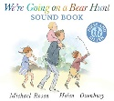  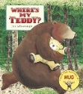  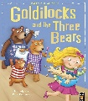  We’re Going On A Bear Hunt By Michael Rosen  Where’s My Teddy By Jed Alborough  Goldilocks And The Three Bears | 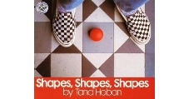  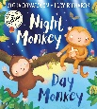  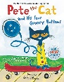  Pete The Cat And His Four Groovy Buttons By Eric Litwin  Night Monkey Day Monkey By Julia Donaldson  Shape Shapes Shapes By Tana Hoban | 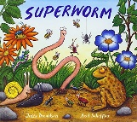  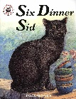  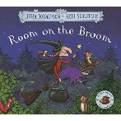  Room On The Broom By Julia Donaldson  Six Dinner Sid By Inga Moore  Superworm By Julia Donaldson | 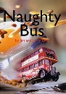  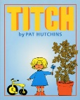  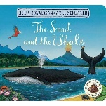  The Snail And The Whale By Julia Donaldson  Titch By Pat Hutchins  Naughty Bus By Jan Oke | 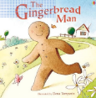  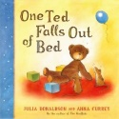  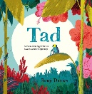  Tad By Benji Davies  One Ted Falls Out Of Bed By Julia Donaldson  Gingerbread Man By Ladybird | 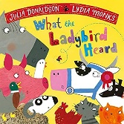  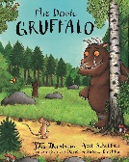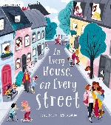  The Gruffalo By Julia Donaldson  In Every House On Every Sheet By Jess Hitchman  What The LadyBird Heard By Julia Donaldson
ELG Number
Have a deep understanding of number to 10, including the composition of each number.
Subitise (recognise quantities without counting) up to 5.
Automatically recall (without reference to rhymes, counting or other aids) number bonds up to 5 (including subtraction facts) and some number bonds to 10, including double facts.
ELG Numerical Patterns
Verbally count beyond 20, recognising the pattern of the counting system.
Compare quantities up to 10 in different contexts, recognising when one quantity is greater than, less than or the same as the other quantity.
Explore and represent patterns within numbers up to 10, including evens and odds, double facts and how quantities can be distributed equally.
Understanding the World
Science | Humans-  Can name and label further body parts.  All about me shoulder, elbow, palm, ankle, fingertips, finger, thumb, eyebrows, eyelashes, crown All About Me  Change and recognise self.  Change, grow, crawl, walk, run, talk, jump, eat, sit, stand, different, similar, short, tall  Identify extended family.  Grandparents, auntie, uncles, cousins All about me  Senses Describe what they can taste, smell, touch, hear, see  salty, sweet, sour, burning, smoky, squishy, hard, soft, smooth, spiky, hot, cold, loud, quiet, whisper, noisy, close, far Throughout year  Materials –Including changing materials  Explore a range of materials, including natural materials. Talks about differences between materials and changes they notice.  harvest fruit/vegetables, seeds, pods, acorns, conkers. conker case, leaves, grains-wheat, oats,  woodland animals- Spiky, smooth, furry, soft,  changing materials -bake, heat, runny, sticky, thick (see also Art & DT)  Explores the natural world around them.  trees, mud, grass, habitat,  Seasons  Names and order seasons.  Autumn, Winter, Spring, Summer, order, first, then, next, last, after, before  Understand the effects of seasons on the natural world, discussing when and how things grow. Name and talk about weather. Autumn 1 & 2 Change Autumn Sleet, hail stones, gales,/strong wind/breeze, shower, leaf fall Hibernate, migrate  Plants  Can talk about different types of plants- All terms plants, bushes, trees, grass, flowers, vegetables  Animals (excluding humans)  Can name, & describe different groups of animals woodland animals, hedgehogs, fox, rabbit, badger,owl, hibernate, hibernate environment, camouflage, on land, in water, migrate throughout year  Explore the natural world around them.(care for environments)  Recycle, reuse, reduce, danger, damage, litter, tidy, rubbish, decay link to R.E. God’s world),  Sound  See Charanga plan for vocabulary | Humans-  Senses Describe what they can taste, smell, touch, hear, see  salty, sweet, sour, burning, smoky, squishy, hard, soft, smooth, spiky, hot, cold, loud, quiet, whisper, noisy, close, far Throughout year  Seasons  Names and order seasons.  Autumn, Winter, Spring, Summer, order, first, then, next, last, after, before  Understand the effects of seasons on the natural world, discussing when and how things grow. Name and talk about weather. Autumn 1 & 2 Change, Autumn Sleet, hail stones, gales,/strong wind/breeze, shower, leaf fall Hibernate, migrate  Plants  Can talk about different types of plants- All terms plants, bushes, trees, grass, flowers, vegetables  Earth & space  moon, planets and stars  sun, moon, Earth, light source, star, planet (names of some), sky, day, night, light, dark, space, astronaut, orbit, rocket, gravity,  Forces  Wind-blow, move,  invisible, & see weather above  Sound  See Charanga plan for vocabulary  Light  light source (space) | Humans-  Senses Describe what they can taste, smell, touch, hear, see  salty, sweet, sour, burning, smoky, squishy, hard, soft, smooth, spiky, hot, cold, loud, quiet, whisper, noisy, close, far Throughout year  Materials –Including changing materials  Explore a range of materials, including natural materials. Talks about differences between materials and changes they notice.  Spring 1 water, ice, frozen, solid, liquid,  changing materials -bake, heat, runny, sticky, thick (see also Art & DT)  Explores the natural world around them.  trees, mud, grass, habitat,  Seasons  Names and order seasons.  Autumn, Winter, Spring, Summer, order, first, then, next, last, after, before  Understand the effects of seasons on the natural world, discussing when and how things grow. Name and talk about weather.  Winter storm, fog, frost, icicles, bare, wind, blow, move, gales, invisible  Light-clouds  Plants  Can talk about different types of plants- All terms plants, bushes, trees, grass, flowers, vegetables  Animals (excluding humans)  Can name, & describe different groups of animals arctic animals, polar bears, penguins, sea lions, seals, reindeer, moose, arctic fox, wolves, environment, camouflage, on land, in water, migrate throughout year  Forces  Explore how to change how things work,  Sound  See Charanga plan for vocabulary  Light  (weather) clouds spring 1 | Humans-  Senses Describe what they can taste, smell, touch, hear, see  salty, sweet, sour, burning, smoky, squishy, hard, soft, smooth, spiky, hot, cold, loud, quiet, whisper, noisy, close, far Throughout year  Seasons  Names and order seasons.  Autumn, Winter, Spring, Summer, order, first, then, next, last, after, before  Understand the effects of seasons on the natural world, discussing when and how things grow. Name and talk about weather  Spring 2 Sum1 (weather dependent) emerge, warmer, growth, buds, leaflets, buds, blossom,  Plants  Can talk about different types of plants- All terms plants, bushes, trees, grass, flowers, vegetables  Can name, & describe different groups of animals African animals lion, zebra, giraffe environment, camouflage, on land, in water, migrate throughout year  Magnetism  attract, repel, Sum 1 & see compass work in geography mapping  Sound  See Charanga plan for vocabulary | Humans-  Senses Describe what they can taste, smell, touch, hear, see  salty, sweet, sour, burning, smoky, squishy, hard, soft, smooth, spiky, hot, cold, loud, quiet, whisper, noisy, close, far Throughout year  Materials –Including changing materials  changing materials -bake, heat, runny, sticky, thick (see also Art & DT)  Explores the natural world around them.  trees, mud, grass, habitat,  Seasons  Names and order seasons.  Autumn, Winter, Spring, Summer, order, first, then, next, last, after, before  Understand the effects of seasons on the natural world, discussing when and how things grow. Name and talk about weather.  Spring 2 Sum1 (weather dependent) emerge, warmer, growth, buds, leaflets, buds, blossom,  dew, sunshine, shadows  Plants  Can talk about different types of plants- All terms plants, bushes, trees, grass, flowers, vegetables  Can explain simple life cycles( bean plant)  Bean plant, stalk, leaf, flowers, tall, bean pods,  Animals-excluding humans  Can explain simple life cycles –frogs & butterflies  Frogspawn, tadpoles, froglet, frog, grow, change, egg, caterpillar, chrysalis/cocoon, butterfly  Can name, & describe different groups of animals- mini beasts, frogs, butterflies, ladybirds, snails, slugs, worms, ants, flies, spiders, woodlice, in water Sum 1  environment, camouflage, on land, in water, migrate throughout year  Sound  See Charanga plan for vocabulary  Forces  Magnetism  attract, repel, Sum 1 & see compass work in geography mapping | Humans-  Senses Describe what they can taste, smell, touch, hear, see  salty, sweet, sour, burning, smoky, squishy, hard, soft, smooth, spiky, hot, cold, loud, quiet, whisper, noisy, close, far Throughout year  Plants  Can talk about different types of plants- All terms plants, bushes, trees, grass, flowers, vegetables  Animals (excluding humans)  Can name, & describe different groups of animals under the sea creatures, sharks, rays, fish, crabs, octopus, whales, in water , ocean Sum 2  environment, camouflage, on land, in water, migrate throughout year  Forces  Explore how to change how things work,  floating & sinking , explore how objects move in water- Summer 2  Float, sink, up, down, heavy, light, surface, bottom, fast/slow & other comparatives & superlatives sum 2 Under the sea  invisible, & see weather above  Sound  See Charanga plan for vocabulary  Light  Transparent/opaque, pale,  Sun,shadows,shady
Geography | Identify features on a simple map. All about me  Tree, House, River, Mountain  Road  Compass and compass points- north, south, east west  Can use maps to locate objects in ‘real life’, for example in the classroom/playground. All about me Rooms, Classroom  Playground, Outside , Inside  Talk about local environments (their road, the park, the library, Eccles, Supermarkets) Local Area Library, swimming pool, Trafford centre, Eccles, Morrisons, Aldi, Smyths, Park, name of their road etc.  Can identify similarities and difference between homes in our country. (Repeat from Nursery due to new cohort of chn) All About Me- Flat  Bungalow, House  Talk about what they see in their own environment (school/home) using a wide range of vocabulary. All about me (Progressive throughout the year)  (Progressive throughout the year: Natural world, seasonal changes, planting activities, harvest, farm, birds, minibeasts etc). | Can name at least one other country.  Christmas around the world  To know how children celebrate their special festivals (other cultures). Christmas around the world) St. Nicholas, Poland, Carp, makowiec (poppy seed roll), India, Christians Tradition, banana/mango tree. Neureos (pastries). Paper lanterns  To compare and contrast differences between homes in other countries (internally / externally).  Three Little Pigs straw, brick, hay  Recognises some environments are different to the one in which they live Three little pigs , Space  Use pictures to compare and contrast environments around the world. Three little pigs, Space planets, sun, moon, earth, star, space, astronaut, rocket.  Talk about what they see in their own environment (school/home) using a wide range of vocabulary  (Progressive throughout the year: Natural world, seasonal changes, planting activities, harvest, farm, birds, minibeasts etc). | Can name at least one other country  Chinese New Year  Winter- Polar regions-Arctic/Antarctic  Can name the 4 countries of the Uk and at least 2 other countries. The Gingerbread Man – travelling round different countries UK  Chinese New Year Winter/Arctic/Antarctic  To compare and contrast differences between homes in other countries (internally / externally).  Arctic igloo  To know how children celebrate their special festivals (other cultures). Chinese New Year-dragon, zodiac animals, lanterns, firecracker, noodles, chopsticks, rituals, rice bowls  Recognises some environments are different to the one in which they live  Chinese New Year  RE: Cafod. poverty, poor, hungry, thirsty, homeless  Use pictures to compare and contrast environments around the world  Chinese New Year  Gingerbread Man- names of countries.  Talk about what they see in their own environment (school/home) using a wide range of vocabulary  (Progressive throughout the year: Natural world, seasonal changes, planting activities, harvest, farm, birds, minibeasts etc). | Can name at least one other country  Handa’s Surprise  Africa, China, Can name the 4 countries of the Uk and at least 2 other countries  Handa’s Surprise  Africa, China, Arctic, Map  Continent, Country, Travel  To make comparisons between life for children in this country and life for children in other countries. Handa’s Surprise  To know that different countries have different homes.  Handa’s Surprise  Similarities, Differences, Huts  Flats, Round house  Pancake Day around the world Sweden, fettsdagen, Brazil, Estonia, Iceland.  Talk about what they see in their own environment (school/home) using a wide range of vocabulary Talk about what they see in their own environment (school/home) using a wide range of vocabulary (Progressive throughout the year: Natural world, seasonal changes, planting activities, harvest, farm, birds, minibeasts etc). | Talk about what they see in their own environment (school/home) using a wide range of vocabulary  (Progressive throughout the year: Natural world, seasonal changes, planting activities, harvest, farm, birds, minibeasts etc). | Recognises some environments are different to the one in which they live  The Train Ride farms, towns, cities, rural areas, urban etc.  Talk about what they see in their own environment (school/home) using a wide range of vocabulary  (Progressive throughout the year: Natural world, seasonal changes, planting activities, harvest, farm, birds, minibeasts etc).
History | Talks about people who help them in their immediate area, i.e. in school and around the school grounds. Nursery & Reception: All About Me  lollipop person, caretaker, office staff, dinner lady,  Can briefly talk about some members of their family.big, small, bigger, smaller  Can talk about past and upcoming events with their immediate family.  (Progressive throughout the year depending on children’s personal events)  soon, later, then, yesterday, tomorrow, next week, a long time ago, special, celebration, gather  Can talk about members of immediate family in more detail. All about me What mum looks like, dad looks like, own likes and dislikes  Can discuss similarities and differences between people in their family.All about me aunties, uncles, cousins, step family, grandparents, second homes, physical features eg hair colour  Sequence family members by explaining who they are. (Autumn 1: All about me)  baby, toddler, child, teenager, adult, elderly  To continue the life sequence and know the differences/changes that happen. All about me  soon, later, years, grow, change, older, younger  Sequence family members explaining who they are and the key differences between what they can/can’t do. All about me  mum, dad, grandparent, sister, brother, cousins, auntie, uncles, crawl, walk, eat, run, walking stick, wheel chair | Can briefly talk about some members of their family.  (R.E.)  Can talk about past and upcoming events with their immediate family.  (Progressive throughout the year depending on children’s personal events)  soon, later, then, yesterday, tomorrow, next week, a long time ago, special, celebration, gather  Can talk about members of immediate family in more detail X AUT 2 R.E.  aunties, uncles, cousins, step family, grandparents, second homes, physical features eg hair colour  Comments on fictional characters in stories. Progressive throughout the year throughout each topic : The Three Little pigs  Kind, mean, not nice, happy, sad, scary, magical  Shares some similarities between characters, figures or objects.  The Three Little pigs  same, similar, different  Compare and contrast characters from stories, sharing similarities and differences.  The Three Little pigs  version, old, new, alternative ending, alternative characters, change, sly, sneaky, selfish, loving, friendly, sweet natured  To comment on historical figures and objects from non-fiction texts, sharing similarities and differences.  link to Space Neil Armstrong | Can talk about past and upcoming events with their immediate family.  (Progressive throughout the year depending on children’s personal events)  soon, later, then, yesterday, tomorrow, next week, a long time ago, special, celebration, gather  Comments on fictional characters in stories. Progressive throughout the year throughout each topic. (Gingerbread Man)  Kind, mean, not nice, happy, sad, scary, magical  Shares some similarities between characters, figures or objects.  Gingerbread Man  same, similar, different  Compare and contrast characters from stories, sharing similarities and differences.  version, old, new, alternative ending, alternative characters, change, sly, sneaky, selfish, loving, friendly, sweet natured | Can talk about past and upcoming events with their immediate family.  (Progressive throughout the year depending on children’s personal events)  soon, later, then, yesterday, tomorrow, next week, a long time ago, special, celebration, gather  Comments on fictional characters in stories. Kind, mean, not nice, happy, sad, scary, magical | Can talk about past and upcoming events with their immediate family.  (Progressive throughout the year depending on children’s personal events)  soon, later, then, yesterday, tomorrow, next week, a long time ago, special, celebration, gather  Can identify emergency situations and know who to call. : Heartstart  999, help, ambulance, hurt, fire, firefighter, fire engine, stolen, police, blue light, siren  Comments on fictional characters in stories. Progressive throughout the year throughout each topic. (Jack and the beanstalk)  Kind, mean, not nice, happy, sad, scary, magical  Shares some similarities between characters, figures or objects.  Jack and the beanstalk  same, similar, different  Compare and contrast characters from stories, sharing similarities and differences.  version, old, new, alternative ending, alternative characters, change, sly, sneaky, selfish, loving, friendly, sweet natured | Can talk about past and upcoming events with their immediate family.  (Progressive throughout the year depending on children’s personal events)  soon, later, then, yesterday, tomorrow, next week, a long time ago, special, celebration, gather  Comments on fictional characters in stories. Progressive throughout the year throughout each topic.  Kind, mean, not nice, happy, sad, scary, magical  Comments on where different vehicles may be seen and know some of the different functions that they have.  The Train Ride  Land, sea, sky, train, aeroplane, helicopter, ships, boats, submarines, trams.  Compare trains, cars and aeroplanes from long ago and now – how were they invented and how have they changed?  The Train Ride  long ago, now, years, old, new, change, modern, history, important, engine, move, drive, fly  To comment on historical figures and objects from non-fiction texts, sharing similarities and differences.  The Wright Brothers,
ELG Past and Present
Talk about the lives of the people around them and their roles in society.
Know some similarities and differences between things in the past and now, drawing on their experiences and what has been read in class.
Understand the past through settings, characters and events encountered in books read in class and storytelling.
ELG People, Culture and Communities
Describe their immediate environment using knowledge from observation, discussion, stories, non-fiction texts and maps.
Know some similarities and differences between different religious and cultural communities in this country, drawing on their experiences and what has been read in class.
Explain some similarities and differences between life in this country and life in other countries, drawing on knowledge from stories, non-fiction texts and (when appropriate) maps.
ELG The Natural World
Explore the natural world around them, making observations and drawing pictures of animals and plants.
Know some similarities and differences between the natural world around them and contrasting environments, drawing on their experiences and what has been read in class.
Understand some important processes and changes in the natural world around them, including the seasons and changing states of matter.
Expressive Arts and Design

 | Music
Learn to sing Nursery Rhymes and Action Songs: | Pat-a-cake  1,2,3,4,5 Once I caught a fish alive  This Old Man  Five Little Ducks  Name Song  Things for Fingers | - I’m A Little Teapot  - The Grand Old Duke Of York  - Ring O’ Roses  - Hickory Dickory Dock  - Not Too Difficult  - The ABC Song | Wind The Bobbin Up  Rock-a-bye Baby  Five Little Monkeys Jumping On The Bed  Twinkle Twinkle  If You're Happy And You Know It  Head, Shoulders, Knees and Toes | - Old Macdonald  - Incy Wincy Spider  - Baa Baa Black Sheep  - Row, Row, Row Your Boat  - The Wheels On The Bus  - The Hokey Cokey | Big Bear Funk is a transition Unit that prepares children for their musical learning in Year 1. | This Unit of Work consolidates the learning that has occurred during the year. All the learning is focused around revisiting chosen nursery rhymes and/or songs, a context for the History of Music and the very beginnings of the Language of Music.
Musical Learning Focus: | - Listening and responding to different styles of music  - Embedding foundations of the interrelated dimensions of music  - Learning to sing or sing along with nursery rhymes and action songs  - Improvising leading to playing classroom instruments  - Share and perform the learning that has taken place | - Listening and responding to different styles of music  - Embedding foundations of the interrelated dimensions of music  - Learning to sing or sing along with nursery rhymes and action songs  - Improvising leading to playing classroom instruments  - Share and perform the learning that has taken place | - Listening and responding to different styles of music  - Embedding foundations of the interrelated dimensions of music  - Learning to sing or sing along with nursery rhymes and action songs  - Improvising leading to playing classroom instruments  - Singing and learning to play instruments within a song  - Share and perform the learning that has taken place | - Listening and responding to different styles of music  - Embedding foundations of the interrelated dimensions of music  - Learning to sing or sing along with nursery rhymes and action songs  - Improvising leading to playing classroom instruments  - Singing and learning to play instruments within a song  - Share and perform the learning that has taken place | - Listening and appraising Funk music  - Embedding foundations of the interrelated dimensions of music using voices and instruments  - Learning to sing Big Bear Funk and revisiting other nursery rhymes and action songs  - Playing instruments within the song  - Improvisation using voices and instruments  - Riff-based composition  - Share and perform the learning that has taken place
DT – Opportunities for Baking | - Baking Bread | - Baking sparklers/smores  - Making Christmas Biscuits | - Making Noodles  - Baking/Decorating Gingerbread Men | - Making/Tasting Pancakes | - Creating Fruit Salad, Fruit Skewers | Making fruit ice lollies  Baking Muffins
Termly Famous Artists | - Andy Warhol – Popart |  | Henry Matisse – Collage |  | Gustav Klimt – Tree of Life
Art & DT | Draw- For example, use more details such as eyelashes, eyebrows, ears, lips, body, limbs, feet.  All about me. Portrait Eyes, hair, nose, mouth, eyelashes, eyebrows ears, lips, teeth, feet, hands, body.  Observe animals/natural world and create simple representations. Eg petals on flowers, leaves, butterflies and caterpillars  Woodland animals eg hedgehogs  Paint- Continue to explore, use and refine a variety of effects, using a range of tools, and becoming more efficient with finer brushes, and more detailed resources., eg cotton buds  Woodland animals  Explore textures and forms such as thicker/runny paint, additions such as glitters, painting with natural resources (eg berry juices)  Mix paints to continue colour exploration- and work on tonal  Thin brushes, thick brushes,  Hold a pencil effectively in preparation for fluent writing - using the tripod grip in almost all cases. Use an efficient digital or preferably tripod grip.  Assessment throughout the year. Assessment at the front of the book too show progress throughout the year. Fine motor activities planned in and interventions for children who are not using the correct grip).  Scissor skills- Thumb up, bi-lateral manipulation, with some accuracy, including curves  (Scissor activities planned in provision – cutting cards, paper etc. Scissors always accessible in creative area for children to use in provision)  (Autumn 1 – creating a face using different features of face on a plate)  Cutting, snipping, scissors, hold, control.  Joining materials- explore using glue sticks, runny glue, sellotape handling, split pins, string, treasury tags Eg refining junk modelling ideas.  To create a house using toilet roll tubes)  Joining vocabulary: split pin, stick, flange, tabs, tie, slot, cellotape, masking tape, junk modelling, runny glue, pva glue, string, treasury tags, glue sticks.  Explore a range of art resources, finer chalk sticks, pencils, crayons, wax crayons, paints, felt tips, natural resources to make transient art, leaves, sticks, shells, stones, seeds and pods | Observe animals/natural world and create simple representations. Eg petals on flowers, leaves, butterflies and caterpillars  Creating a leaf man leaves, colours, arms, legs, body.  Paint- Continue to explore, use and refine a variety of effects, using a range of tools, and becoming more efficient with finer brushes, and more detailed resources., eg cotton buds  using forks in paint to create a firework picture)  Explore textures and forms such as thicker/runny paint, additions such as glitters, painting with natural resources (eg berry juices)  Mix paints to continue colour exploration- and work on tonal colours by adding white, black, or primary colours to explore tonal ranges, eg light pink, dark pink.  Thin brushes, thick brushes,  Assessment throughout the year. Assessment at the front of the book too show progress throughout the year. Fine motor activities planned in and interventions for children who are not using the correct grip).  Scissor skills- Thumb up, bi-lateral manipulation, with some accuracy, including curves  (Scissor activities planned in provision – cutting cards, paper etc. Scissors always accessible in creative area for children to use in provision)  (Autumn 2 – cutting pictures out of a catalogue to create a Christmas List)  Cutting, snipping, scissors, hold, control.  Joining materials- explore using glue sticks, runny glue, sellotape handling, split pins, string, treasury tags Eg refining junk modelling ideas.  Create a space rocket using junk modelling/tubes using sellotape and masking tape to join together)  Joining vocabulary: split pin, stick, flange, tabs, tie, slot, cellotape, masking tape, junk modelling, runny glue, pva glue, string, treasury tags, glue sticks.  Explore a range of art resources, finer chalk sticks, pencils, crayons, wax crayons, paints, felt tips, natural resources to make transient art, leaves, sticks, shells, stones, seeds and pods | Draw- For example, use more details such as eyelashes, eyebrows, ears, lips, body, limbs, feet.  Draw weather pictures  Observe animals/natural world and create simple representations. Eg petals on flowers, leaves, butterflies and caterpillars  Creating a stick man sticks, size, short, long, join, arms, legs, body.  Paint- Continue to explore, use and refine a variety of effects, using a range of tools, and becoming more efficient with finer brushes, and more detailed resources., eg cotton buds  Create a Valentine card using cotton buds  Explore textures and forms such as thicker/runny paint, additions such as glitters, painting with natural resources (eg berry juices)  Mix paints to continue colour exploration- and work on tonal colours by adding white, black, or primary colours to explore tonal ranges, eg light pink, dark pink.  Thin brushes, thick brushes,  (Assessment throughout the year. Assessment at the front of the book too show progress throughout the year. Fine motor activities planned in and interventions for children who are not using the correct grip).  Scissor skills- Thumb up, bi-lateral manipulation, with some accuracy, including curves  (Scissor activities planned in provision – cutting cards, paper etc. Scissors always accessible in creative area for children to use in provision)  (Spring 1 – cutting out different parts of the body to create a gingerbread man)  Cutting, snipping, scissors, hold, control.  Joining materials- explore using glue sticks, runny glue, sellotape handling, split pins, string, treasury tags Eg refining junk modelling ideas.  Create a whole class junk modelling Chinese New Year Dragon  Joining vocabulary: split pin, stick, flange, tabs, tie, slot, cellotape, masking tape, junk modelling, runny glue, pva glue, string, treasury tags, glue sticks.  Explore a range of art resources, finer chalk sticks, pencils, crayons, wax crayons, paints, felt tips, natural resources to make transient art, leaves, sticks, shells, stones, seeds and pods | Draw- For example, use more details such as eyelashes, eyebrows, ears, lips, body, limbs, feet.  Mother’s Day Portrait Eyes, hair, nose, mouth, eyelashes, eyebrows ears, lips, teeth, feet, hands, body  Paint- Continue to explore, use and refine a variety of effects, using a range of tools, and becoming more efficient with finer brushes, and more detailed resources., eg cotton buds  using thin brushes to create an Easter card using pastel/water colours)  Explore textures and forms such as thicker/runny paint, additions such as glitters, painting with natural resources (eg berry juices)  Mix paints to continue colour exploration- and work on tonal colours by adding white, black, or primary colours to explore tonal ranges, eg light pink, dark pink.  Thin brushes, thick brushes,  Assessment throughout the year. Assessment at the front of the book too show progress throughout the year. Fine motor activities planned in and interventions for children who are not using the correct grip).  Scissor skills- Thumb up, bi-lateral manipulation, with some accuracy, including curves  Scissor activities planned in provision – cutting cards, paper etc. Scissors always accessible in creative area for children to use in provision)  (Summer 1 – cutting out minibeasts to create a minibeast scene)  Cutting, snipping, scissors, hold, control.  Joining materials- explore using glue sticks, runny glue, sellotape handling, split pins, string, treasury tags Eg refining junk modelling ideas.  Create a superhero using split pins/treasury tags  Joining vocabulary: split pin, stick, flange, tabs, tie, slot, cellotape, masking tape, junk modelling, runny glue, pva glue, string, treasury tags, glue sticks.  Explore a range of art resources, finer chalk sticks, pencils, crayons, wax crayons, paints, felt tips, natural resources to make transient art, leaves, sticks, shells, stones, seeds and pods | Draw- For example, use more details such as eyelashes, eyebrows, ears, lips, body, limbs, feet. Observational art see below  Observe animals/natural world and create simple representations. Eg petals on flowers, leaves, butterflies and caterpillars  Jack and the beanstalk – painting a flower plants, beanstalk, bean, seed, root, flowers, petal, stem, leaves.  The Very Hungry Caterpillar butterfly, chrysalis, caterpillar, life cycle, symmetry  Paint- Continue to explore, use and refine a variety of effects, using a range of tools, and becoming more efficient with finer brushes, and more detailed resources., eg cotton buds  Using thin brushes to create an observational painting of a minibeast  Explore textures and forms such as thicker/runny paint, additions such as glitters, painting with natural resources (eg berry juices)  Mix paints to continue colour exploration- and work on tonal colours by adding white, black, or primary colours to explore tonal ranges, eg light pink, dark pink.  Thin brushes, thick brushes,  Assessment throughout the year. Assessment at the front of the book too show progress throughout the year. Fine motor activities planned in and interventions for children who are not using the correct grip).  Scissor skills- Thumb up, bi-lateral manipulation, with some accuracy, including curves  (Scissor activities planned in provision – cutting cards, paper etc. Scissors always accessible in creative area for children to use in provision)  (Summer 1 – cutting out minibeasts to create a minibeast scene)  Cutting, snipping, scissors, hold, control.  Joining materials- explore using glue sticks, runny glue, sellotape handling, split pins, string, treasury tags Eg refining junk modelling ideas.  Create a minibeast split pin character  Joining vocabulary: split pin, stick, flange, tabs, tie, slot, cellotape, masking tape, junk modelling, runny glue, pva glue, string, treasury tags, glue sticks.  Explore a range of art resources, finer chalk sticks, pencils, crayons, wax crayons, paints, felt tips, natural resources to make transient art, leaves, sticks, shells, stones, seeds and pods | Observe animals/natural world and create simple representations. Eg petals on flowers, leaves, butterflies and caterpillars  Under the sea draw fish, crabs, sharks  Paint- Continue to explore, use and refine a variety of effects, using a range of tools, and becoming more efficient with finer brushes, and more detailed resources., eg cotton buds  using different textures to create a painting of a under the sea anima)  Explore textures and forms such as thicker/runny paint, additions such as glitters, painting with natural resources (eg berry juices)  Mix paints to continue colour exploration- and work on tonal colours by adding white, black, or primary colours to explore tonal ranges, eg light pink, dark pink.  Thin brushes, thick brushes,  Assessment throughout the year. Assessment at the front of the book to show progress throughout the year. Fine motor activities planned in and interventions for children who are not using the correct grip).  Scissor skills- Thumb up, bi-lateral manipulation, with some accuracy, including curves  (Scissor activities planned in provision – cutting cards, paper etc. Scissors always accessible in creative area for children to use in provision)  (Summer 2- cutting out transport and sticking it in the correct place. Land, air, sea)  Cutting, snipping, scissors, hold, control.  Joining materials- explore using glue sticks, runny glue, sellotape handling, split pins, string, treasury tags Eg refining junk modelling ideas.  Create a vehicle/sea creature made out of junk modelling independently  Joining vocabulary: split pin, stick, flange, tabs, tie, slot, cellotape, masking tape, junk modelling, runny glue, pva glue, string, treasury tags, glue sticks.  Explore a range of art resources, finer chalk sticks, pencils, crayons, wax crayons, paints, felt tips, natural resources to make transient art, leaves, sticks, shells, stones, seeds and pods
ELG Creating with Materials
Safely use and explore a variety of materials, tools and techniques, experimenting with colour, design, texture, form and function.
Share their creations, explaining the process they have used.
Make use of props and materials when role playing characters in narratives and stories.
ELG Being Imaginative and Expressive
Invent, adapt and recount narratives and stories with peers and their teacher.
Sing a range of well-known nursery rhymes and songs.
Perform songs, rhymes, poems and stories with others, and (when appropriate) try to move in time with music.

