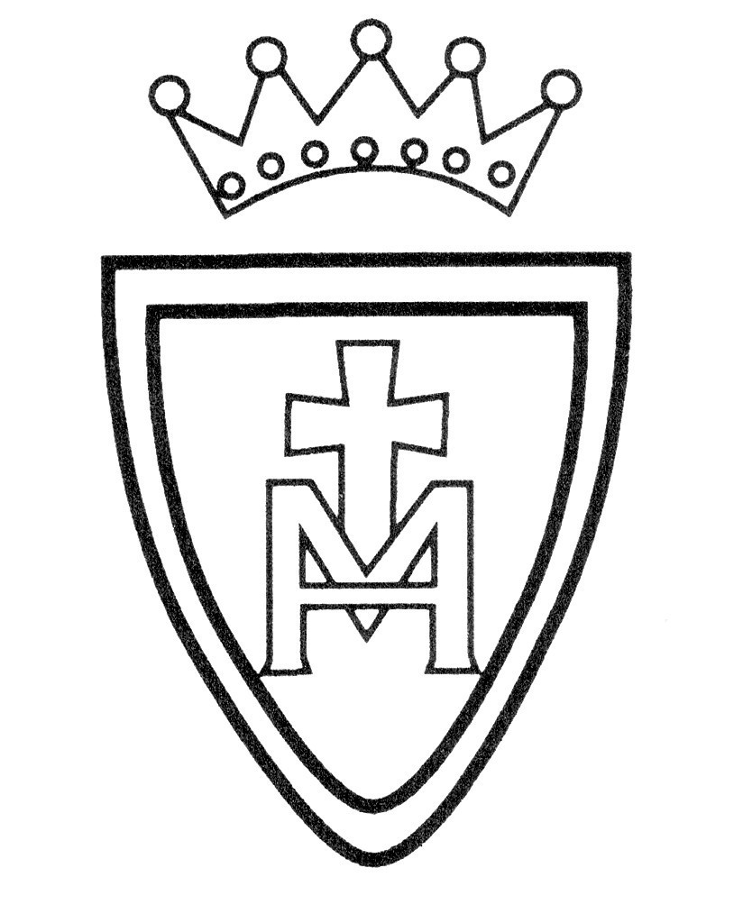

“**We Share, We Value, We Respect”**

**Subject Leader’s Knowledge Progression**

**History**

|  |  |  |  |  |
| --- | --- | --- | --- | --- |
| **Year Group** |  | **Unit Title** | **NC** | **Key Knowledge:** |
| Nursery and Reception |  | Understanding the World (People and Communities) |  | Children talk about past and present events in their own lives and in the lives of family members. They know about similarities and differences between themselves and others, and among families, communities and traditions. |
| Nursery and Reception |  | Understanding the World (The World) |  | Children know about similarities and differences in relation to places, objects, materials and living things. They talk about the features of their own immediate environment and how environments might vary from one another |
| Y1 |  | Our Church and School | *changes within living memory. Where appropriate, these should be used to reveal aspects of change in national life  significant historical events, people and places in their own locality. | Which is older – our church or our school?  Has our school always been here?  What has changed in our school and in our church |
| Y1 |  | Gunpowder Plot | ▪ the lives of significant individuals in the past who have contributed to national and international achievements, | What was the Gunpowder Plot?  The Gunpowder Plot was a plot to kill King James I and his government by blowing up the Houses of Parliament.  Who was involved in the plot?  Robert Catesby, Guy Fawkes, Thomas Percy, and five of their friends were involved.  Why were they plotting?  Under the rule of James I, Catholics were treated unfairly. The plotters were all Catholic and wanted King James removed from the throne.  How was the plot stopped?  A letter was sent to Lord Monteagle, who was due to go to the Houses of Parliament, warning him of the plot. He told the king, who sent guards to search the cellars. They found Guy Fawkes and gunpowder.  Why do we celebrate Bonfire Night?  King James I ordered that people should celebrate his survival on the 5th November. To this day, people still light bonfires and burn ‘guys’ (puppets made of straw, named after Guy Fawkes) to celebrate. |
| Y1 |  | Travel and Transport | changes within living memory. Where appropriate, these should be used to reveal aspects of change in national life | What was a long boat?  Longboats were used by Vikings to travel from one country to another.  What were sedan chairs?  Comfortable chairs used by wealthy people, carried by servants.  What was a horse and cart used for?  Horse and carts were used by people to transport good from one place to another.  What was a penny farthing?  A bicycle with one wheel larger than the other.  How did steam locomotives change lives?  The changed the way people and goods travelled. It allowed poorer people to make journeys to the coast.  Who invented the first aeroplane?  The Wright brothers were the first people to successfully fly a plane. |

|  |  |  |  |  |
| --- | --- | --- | --- | --- |
| **Year Group** |  | **Unit Title** | **NC** |  |
| Y2 |  | Eccles Cenotaph | significant historical events, people and places in their own locality. | Where is Eccles Cenotaph?  When was World War 1  July 1914- November 2018  Who do we remember?  700,000 UK soldiers  When is Remembrance Day?  11th November |
| Y2 |  | Florence Nightingale , Mary Seacole & Edith Cavell | ▪ the lives of significant individuals in the past who have contributed to national and international achievements, [Mary Seacole and/or Florence Nightingale and Edith Cavell] | Who was Mary Seacole?  What is Mary Seacole remembered for?  Who was Florence Nightingale?  What is Florence Nightingale remembered for?  Who was Edith Cavell?  What is Edith Cavell remembered for? |
| Y2 |  | Great Fire of London | events beyond living memory that are significant nationally or globally [for example, the Great Fire of London, the first aeroplane flight or events commemorated through festivals or anniversaries] | When and where did the fire start?  The fire started on Sunday 2nd September 1666 in Thomas Farriner’s bakery on Pudding Lane. Why did the fire start? The fires used for baking were not put out properly.  Why did the fire spread so quickly?  In 1666, the buildings in London were made of wood and straw and they were very close together, making it easy for the flames to spread. It had also been a dry summer, so the buildings were dry. Strong winds were blowing, which helped the flames to spread.  How did people try to put the fire out?  People used leather buckets and water squirts to try to put the fire out, but these did not work. Later in the week, King Charles II ordered buildings to be pulled down to stop the flames from spreading.  How and when was the fire put out?  By Thursday 6th September, the wind had died down. This meant that people were able to put out the flames |

|  |  |  |  |  |
| --- | --- | --- | --- | --- |
| **Year Group** |  | **Unit Title** | **NC** |  |
| Y3 |  | Rainhill Trials and George Stephenson | a study of an aspect or theme in British history that extends pupils’ chronological knowledge beyond 1066 (First railways) | Who was George Stephenson?  Why the line that passes through Eccles is significant.  What happened in the Rainhill Trials?  What happened to William Huskisson? |
| Y3 |  | Stone Age to Iron Age | ▪ changes in Britain from the Stone Age to the Iron Age | Know where the Stone Age gets its name.  Know which tools were crucial to the survival of early man.  Explain how Skara Brae was discovered.  Know the names of some items found at Skara Brae.  Explain why children worked in copper mines.  Give reasons why Iron Age people wanted to protect their homes. |
| Y3 |  | Ancient Greeks | ▪ Ancient Greece – a study of Greek life and achievements and their influence on the western world | What were the city states of Athens and Sparta,  How did Greeks fight?  What was everyday life like?  What were their beliefs?  What is interesting about their culture, and Greek mythology? |

|  |  |  |  |  |
| --- | --- | --- | --- | --- |
| **Year Group** |  | **Unit Title** | **NC** |  |
| Y4 |  | Mayan Civilisation | the achievements of the earliest civilizations – an overview of where and when the first civilizations appeared and a depth study of one of the following: Ancient Sumer; The Indus Valley; Ancient Egypt; The Shang Dynasty of Ancient China | Where and when did the Maya live?  What was Maya writing like?  How did the Maya tell the time?  What numbers did the Maya use in Maths?  Did the Maya play football like us?  How do we know about the Maya? |
| Y4 |  | Anglo Saxons and Scots | ▪ Britain’s settlement by Anglo-Saxons and Scots | Why did the Romans leave?  Who were Hengest and Horsa?  Where did many cities, towns and villages get their name?  What is a Pagan, what did many Anglo-Saxons believe?  How did Christianity spread in the British Isles? |
| Y4 |  | Roman Empire and its impact on Britain | the Roman Empire and its impact on Britain | Why did the Romans invade Britain?  What kind of men could join the Roman Army?  Who was Boudicca and why do we remember her?  What was life like in Roman Britain? |

|  |  |  |  |  |
| --- | --- | --- | --- | --- |
| **Year Group** | **Term** | **Unit Title** | **NC** |  |
| Y5 |  | Leisure and Entertainment | a study of an aspect or theme in British history that extends pupils’ chronological knowledge beyond 1066 | I can understand how cinema changed over the 20th century.  I can understand how and why football changed over the 20th century.  I can understand how young people’s lives were different in the 1960s compared with today  I can understand why Holiday Camps became popular in Britain.  I can understand how important television has been to British people  I can see how changes in 20th century technology affect our lives today |
| Y5 |  | Manchester Industrial Revolution and Canals | a local history study (a study of an aspect of history or a site dating from a period beyond 1066 that is significant in the locality) | What was Manchester like before the industrial revolution?  Why was Manchester a ‘hive of industry’?  How did Manchester change during the period?  What evidence is there of the revolution now? |
| Y5 |  | Tudor Monarchs | a study of an aspect or theme in British history that extends pupils’ chronological knowledge beyond 1066  **Examples (non-statutory) ▪ the changing power of monarchs** | What happened at the Battle of Bosworth?  What was the war of the roses?  Who Was Henry VIII?  Why did Henry break from Rome?  To know who Edward VI was  To understand why Queen Mary I was considered a ‘bloody’ monarch.  To understand how and why Elizabeth I controlled the image which people had of her. |

|  |  |  |  |  |
| --- | --- | --- | --- | --- |
| **Year Group** | **Term** | **Unit Title** | **NC** |  |
| Y6 |  | Christmas Blitz  Salford and WW2 | ▪ a local history study (a study of an aspect of history or a site dating from a period beyond 1066 that is significant in the locality) | How significant was the Blitz?  What was the impact of World War II on people in our locality?  How well does a fictional story tell us what it was like to be an evacuee? |
| Y6 |  | Vikings | the Viking and Anglo-Saxon struggle for the Kingdom of England to the time of Edward the Confessor | What is a Viking?  Where are English people from?  Are English people immigrants?  Where does our town’s name come from?  Were Vikings really brutal invaders? |
| Y6 |  | Ancient Egypt | the achievements of the earliest civilizations – an overview of where and when the first civilizations appeared and a depth study of one of the following: Ancient Sumer; The Indus Valley; Ancient Egypt; The Shang Dynasty of Ancient China | Who built the Great Pyramid at Giza?  Why did Hatshepsut send an expedition to Punt?  What did Akhenaten do that made him so hated?  What happened to Akhenaten’s successors?  Why do we remember Ramesses II?  How did Ptolemy II contribute to trade? |

*“On our journey of faith, with Jesus as our guide, we share friendship, value learning and show*

*respect for ourselves and others, as we live, learn, play, work and pray together in our community.”*